1. Create an HTML file with the basic structure including <!DOCTYPE html>, <html>, <head>, and <body> tags.

<!DOCTYPE html>

<html>

<head>

</head>

<body>

<h1>BasicHTMLTags</h1>

<p>Doctype, html, head, body</p>

</body>

</html>

Output:

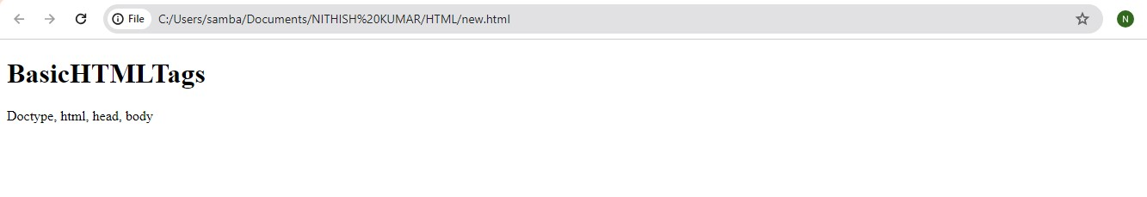

1. Add a title to your HTML page using the <title> tag.

<!DOCTYPE html>

<html>

<head>

<title>This is the Title of page</title>

</head>

<body>

<h3>Title tag</h3>

<p>This is for title</p>

</body>

</html>

Output:

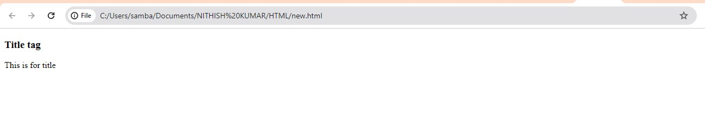

1. Create a paragraph using the <p> tag and add some text inside it.

<!DOCTYPE html>

<html>

<head>

<title>Paragraph</title>

</head>

<body>

<h1>Paragrph Tag</h1>

<p>

It is paragraph. In this tag, paragraph can be written.

</p>

</body>

</html>

Output:

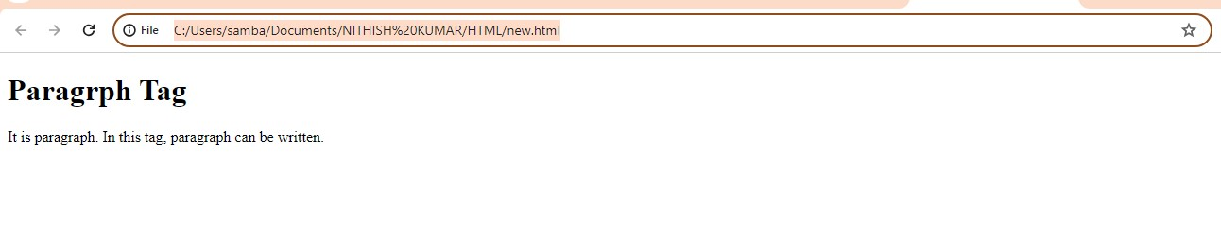

1. Create a heading using the <h1> tag and add a title to your page.

<!DOCTYPE html>

<html>

<head>

<title>Heading</title>

</head>

<body>

<h1>Heading tag</h1>

<p>

Heading of the page.

</p>

</body>

</html>

Output:

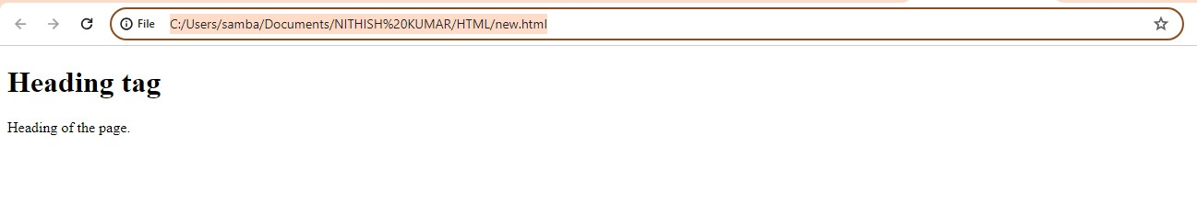

1. Create an unordered list using the <ul> tag with at least 3 list items using <li> tags.

<!DOCTYPE html>

<html>

<head>

</head>

<body>

<h2>Unordered List</h2>

<ul>

<li>Mango</li>

<li>Orange</li>

<li>Pineapple</li>

</ul>

</body>

</html>

Output:

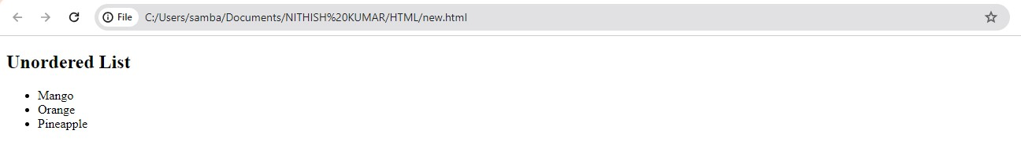

1. Create an ordered list using the <ol> tag with at least 3 list items using <li> tags.

<!DOCTYPE html>

<html>

<head>

</head>

<body>

<h2>Ordered List</h2>

<ol>

<li>Java</li>

<li>HTML</li>

<li>SQL</li>

</ol>

</body>

</html>

Output:

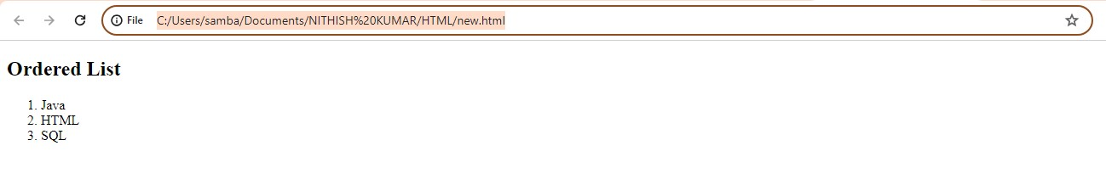

1. Create a hyperlink using the <a> tag to link to an external website.

<!DOCTYPE html>

<html>

<head>

<title>Hyperlink</title>

</head>

<body>

<h2>Microsoft Website</h2>

<p>Click below link</p>

<a href="https://www.microsoft.com/en-in">Microsoft website</a>

</body>

</html>

Output:

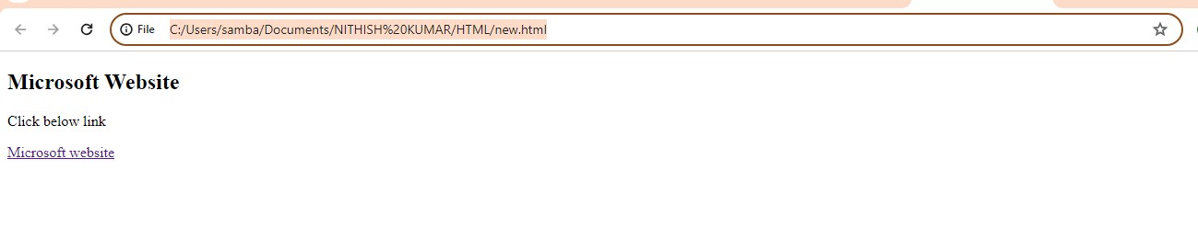

1. Insert an image into your HTML page using the <img> tag.

<!DOCTYPE html>

<html>

<head>

<title>Image</title>

</head>

<body>

<h2>Image of a car</h2>

<img src="https://www.globalbrandsmagazine.com/wp-content/uploads/2021/02/RollsRoyce-Phantom-VIII-Exterior-103696.jpg">

</body>

</html>

Output:

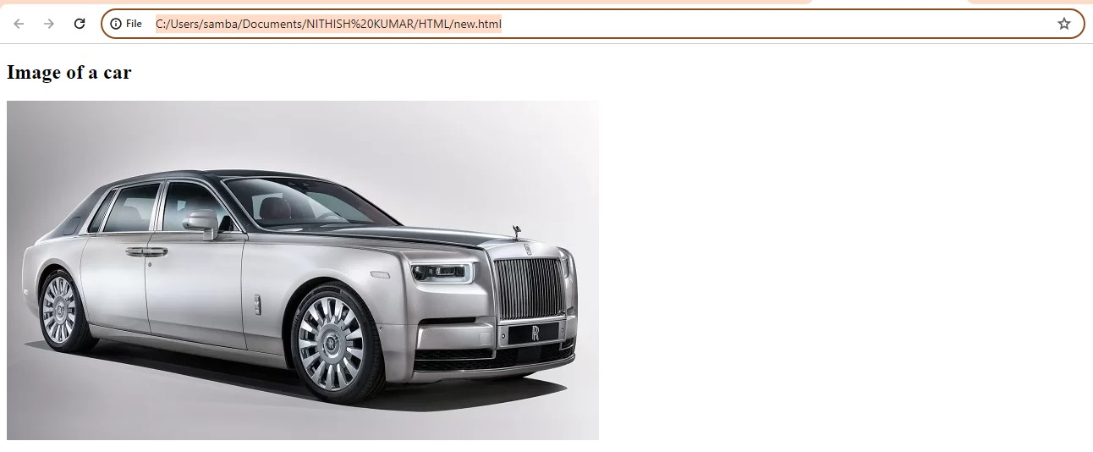

1. Add a background color to your HTML page using the background-color property in CSS.

<!DOCTYPE html>

<html>

<head>

<title>Background</title>

</head>

<body>

<h1 style="background-color: orange;">Background color is Orange</h1>

</body>

</html>

Output:

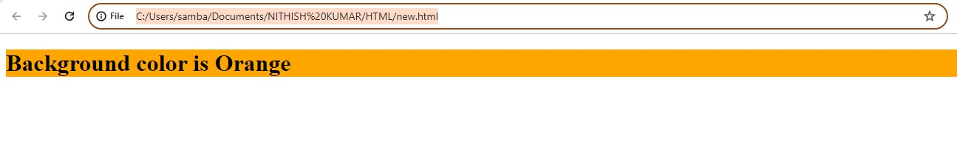

1. Set a background image for your HTML page using the background-image property in CSS.

<!DOCTYPE html>

<html>

<head>

<title>Background</title>

</head>

<body>

<h2 style="background-image: url(https://cdn.britannica.com/84/73184-050-05ED59CB/Sunflower-field-Fargo-North-Dakota.jpg);

width: 400px;

height: 300px;">

Background image

</h2>

<p>Background image is sunflowers</p>

</body>

</html>

Output:

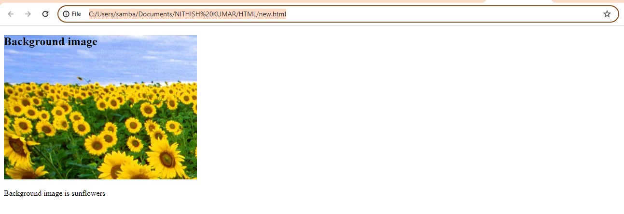

1. Create a table using the <table> tag with at least 3 rows and 3 columns using <tr>, <td>, and <th> tags.

<!DOCTYPE html>

<html>

<head>

<title>Table</title>

</head>

<body>

<h1>Table</h1>

<table border="1px" style="padding: 5px;width: 500px;height: 300px;">

<tr>

<th>State</th>

<th>Capital City</th>

<th>Type of city</th>

</tr>

<td>Telangana</td>

<td>Hyderabad</td>

<td>Metropolitan</td>

</tr>

<tr>

<td>Maharstra</td>

<td>Mumbai</td>

<td>Metropolitan</td>

</tr>

<tr>

<td>Karnataka</td>

<td>Bangalore</td>

<td>Metropolitan</td>

</tr>

</table>

</body>

</html>

Output:

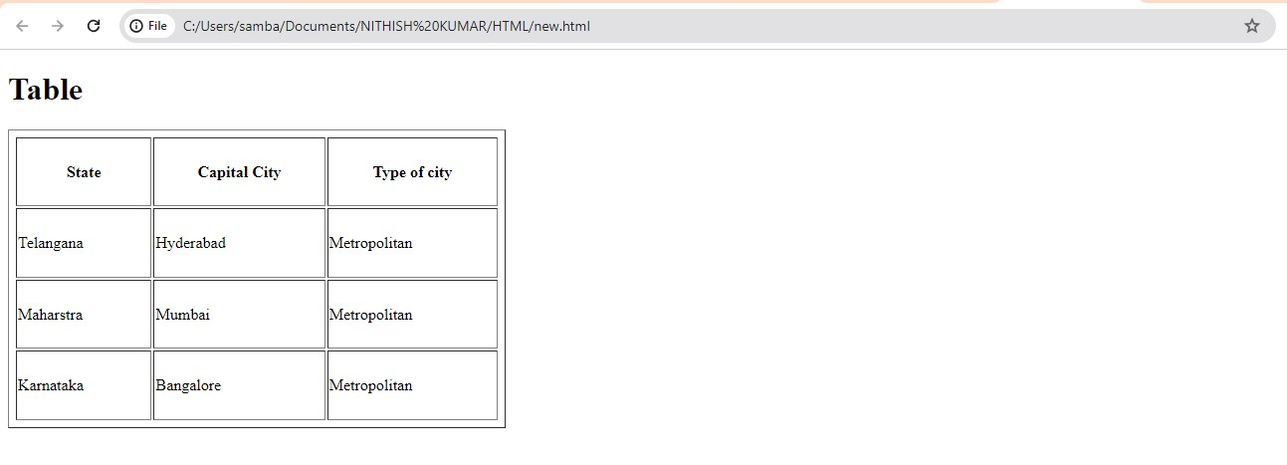

1. Merge cells in a table using the rowspan and colspan attributes.

<!DOCTYPE html>

<html>

<head>

<title>Table</title>

</head>

<body>

<h1>Table</h1>

<table border="2px">

<tr>

<th>State</th>

<th>City</th>

<th>Capital</th>

</tr>

<tr>

<td rowspan="3">Telangana</td>

<td colspan="2">Hyderabad</td>

<tr>

<td>Khammam</td>

</tr>

<tr>

<td>Suryapet</td>

</tr>

<tr>

<td rowspan="2">Andhra Pradesh</td>

<td colspan="2">Amaravathi</td>

</tr>

<tr>

<td>Kakinada</td>

</tr>

<tr>

<td>Karnataka</td>

<td colspan="2">Bangalore</td>

</tr>

</table>

</body>

</html>

Output:

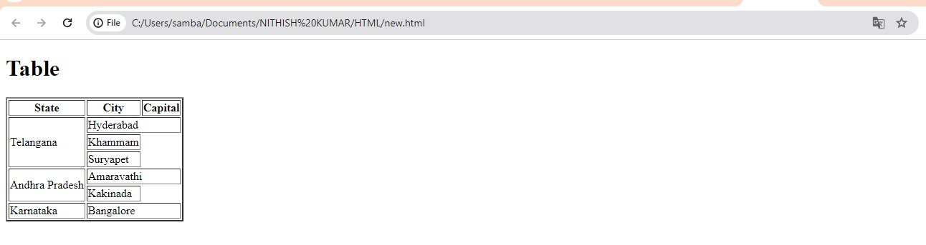

1. Create a div element using the <div> tag and add some text inside it.

<!DOCTYPE html>

<html>

<head>

<title>Division</title>

</head>

<body>

<h1>Division Tag</h1>

<div>

<h2>First division</h2>

<p>First paragraph.</p>

</div>

<div>

<h3>Second division</h3>

<p>Second paragraph.</p>

</div>

</body>

</html>

Output:

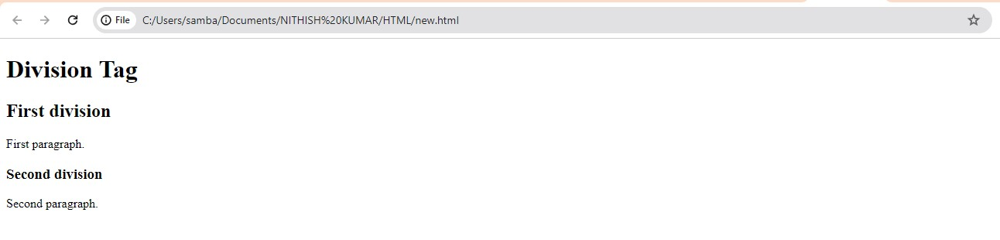

1. Create a button using the <button> tag and add some text inside it.

<!DOCTYPE html>

<html>

<head>

<title><Button></title>

</head>

<body>

<h1>Button Tag</h1>

<button type="button">Click!</button>

</body>

</html>

Output:

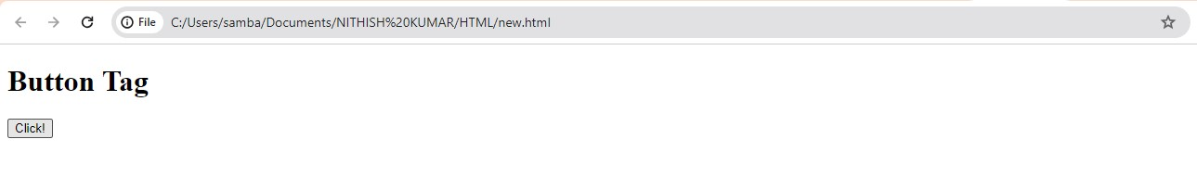

1. Use the <hr> tag to insert a horizontal line in your HTML page.

<!DOCTYPE html>

<html>

<head>

<title>Horizontal Ruler</title>

</head>

<body>

<h1>Horizontal Ruler</h1>

<p>This is the example of hr tag</p>

<hr>

</body>

</html>

Output:

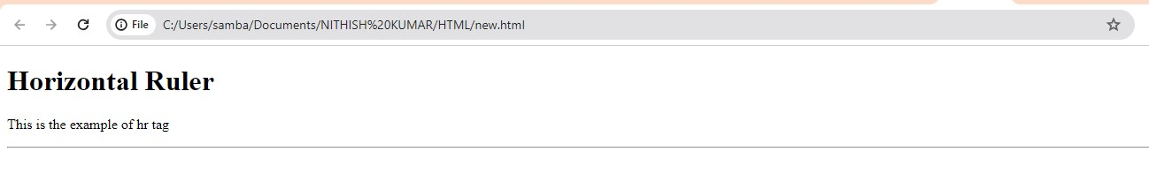

1. Create a form using the <form> tag with input fields like text, password, radio buttons, checkboxes, and a submit button.

<!DOCTYPE html>

<html>

<head>

<title>Form</title>

</head>

<body>

<h1>Form</h1>

<form action="">

Name:<input type="text"><br>

Password:<input type="password" name="password"><br>

<input type="radio" id="Male" value="Male">

<label for="Male">Male</label>

<input type="radio" id="Female">

<label for="Female">Female</label><br>

<input type="checkbox" name="check" id="check">

<label for="check">check it</label><br>

<input type="submit" name="click to sumbit!">

</form>

</body>

</html>

Output:

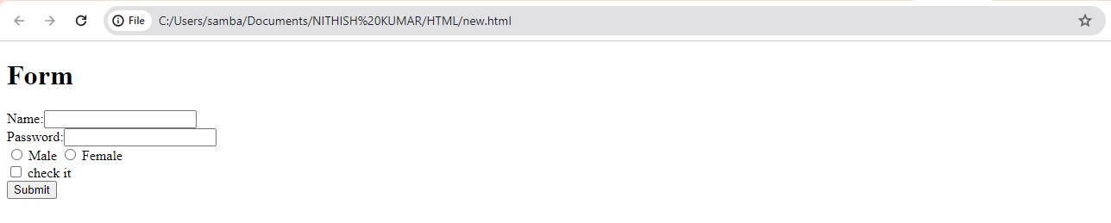

1. Embed a YouTube video using the <iframe> tag.

<!DOCTYPE html>

<html>

<head>

<title>IFrame</title>

</head>

<body>

<h1>Iframe Tag</h1>

<iframe src="https://youtu.be/f06SjPc_y1c" frameborder="2px" height="300px" width="500px"></iframe>

</body>

</html>

1. Create an ordered list with a nested unordered list inside it.

<!DOCTYPE html>

<html>

<head>

<title>Nested Ordered List</title>

</head>

<body>

<h2>Ordered list with nested unordered list</h2>

<ol>

<ul>

<li>Toyota</li>

<li>Tata Motors</li>

<li>Mahindra</li>

</ul>

</ol>

</body>

</html>

Output:

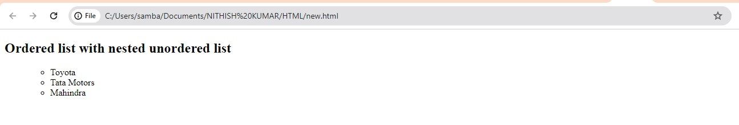

1. Use the <blockquote> tag to quote a block of text.

<!DOCTYPE html>

<html>

<head>

<title>Blockquote</title>

</head>

<body>

<h2>Blockquote Tag </h2>

<blockquote>This is a blockquote tag text</blockquote>

</body>

</html>

Output:



1. Create a definition list using the <dl>, <dt>, and <dd> tags.

<!DOCTYPE html>

<html>

<head></head>

<body>

<h1>Definition List</h1>

<dl>

<dt>HTML</dt>

<dd>Hyper Text Markup Laguage</dd>

</dl>

</body>

</html>

Output:

